Cryptography Fundamentals

LAB DIGITAL ASSIGNMENT -1

NAME: ANIRUDH KUMAR

REG NO: 19BCI0246

Caesar cipher:

Aim: To implement Caesar cipher to encrypt and decrypt a given text.

Procedure:

For encryption:

* Traverse the given text one character at a time.
* For each character ch: ch=(ch+3)%26.
* Return the new string generated.

For decryption:

* Traverse the given text one character at a time.
* For each character ch: ch=(ch-3)%26.
* Return the new string generated.

Code:

def encrypt(st):

res=""

for i in st:

if(i.islower()):

res=res+chr((ord(i)+3-97)%26 +97)

else:

res=res+chr((ord(i)+3-65)%26 +65)

return res

def decrypt(st):

res=""

for i in st:

if(i.islower()):

res=res+chr((ord(i)-3-97)%26 + 97)

else:

res=res+chr((ord(i)-3-65)%26 + 65)

return res

choice=0

doagain=1

print('19BCI0246 ANIRUDH KUMAR')

print('CAESAR CIPHER')

while(doagain==1):

string=input('Enter text to be encrypted/decrypted ')

print('Enter 1 to encrypt and 2 to decrypt ')

choice=int(input())

if choice==1:

print(encrypt(string))

elif choice==2:

print(decrypt(string))

doagain=int(input('Do again? 1-Yes 0-No '))

Screenshot of code:

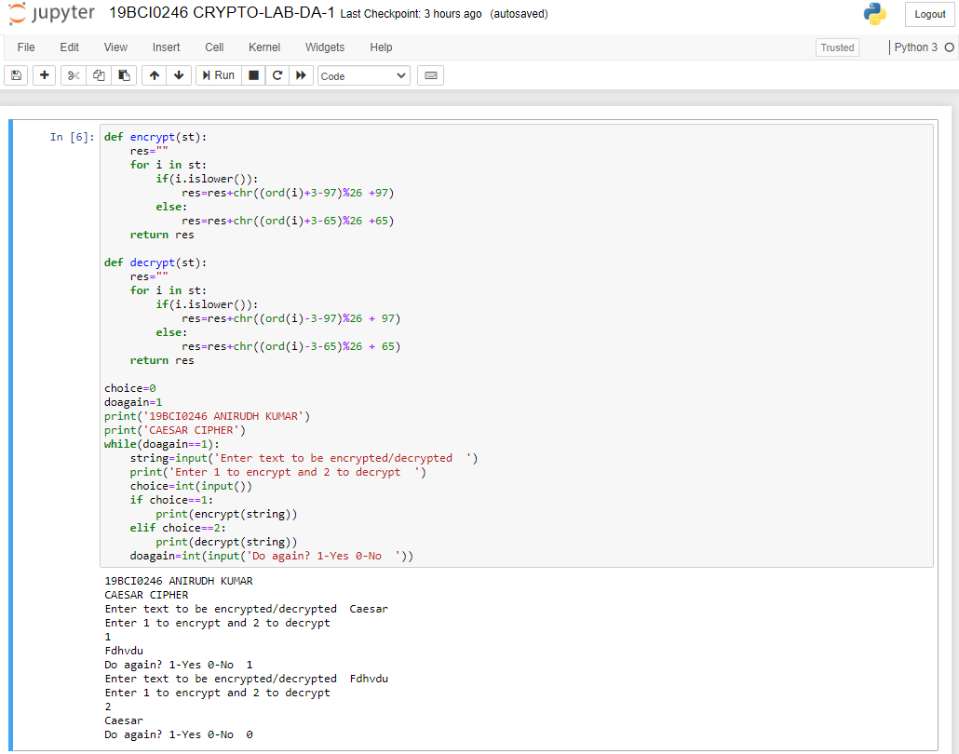

OUTPUT:

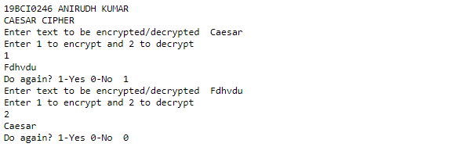

Playfair cipher:

Aim: To implement Playfair cipher to encrypt and decrypt a given text.

Procedure:

For encryption:

* Generate the key matrix: All letters to be placed in the 5x5 matrix. First, the letters in the key. Then, the other letters in ascending order
* If the plaintext contains J, replace with I.
* To encrypt the plaintext: The text is split into pairs of 2 letters. If there is an odd number of letters, a dummy letter x is added to the last letter.
* Rules for encryption:
  1. If letters in the same row: take letter to left of each letter.
  2. If letters in same column, take letter below each letter.
  3. Else: Form a rectangle with the 2 letters and take the letters on the horizontal opposite corner of the rectangle.
* Print the encrypted string.

For decryption:

* Generate the key matrix at the receiver’s end: All letters to be placed in the 5x5 matrix. First, the letters in the key. Then, the other letters in ascending order. J is replaced by I.
* To decrypt the ciphertext: The text is split into pairs of 2 letters.
* Rules for decryption:

1. If letters in same row: take letter to right of each letter.
2. If letters in same column: take letter above each letter.
3. Else: Form a rectangle with the two letters and take the letters on horizontal opposite corner of the rectangle.

* Print the decrypted string.

Code:

def matrix(x,y,initial):

return [[initial for i in range(x)] for j in range(y)]

result=list()

for c in key:

if c not in result:

if c=='J':

result.append('I')

else:

result.append(c)

flag=0

for i in range(65,91):

if chr(i) not in result:

if i==73 and chr(74) not in result:

result.append("I")

flag=1

elif flag==0 and i==73 or i==74:

pass

else:

result.append(chr(i))

k=0

my_matrix=matrix(5,5,0)

for i in range(0,5):

for j in range(0,5):

my_matrix[i][j]=result[k]

k+=1

def locindex(c):

loc=list()

if c=='J':

c='I'

for i ,j in enumerate(my_matrix):

for k,l in enumerate(j):

if c==l:

loc.append(i)

loc.append(k)

return loc

def encrypt():

msg=str(input("ENTER MSG: "))

msg=msg.upper()

msg=msg.replace(" ", "")

i=0

for s in range(0,len(msg)+1,2):

if s<len(msg)-1:

if msg[s]==msg[s+1]:

msg=msg[:s+1]+'X'+msg[s+1:]

if len(msg)%2!=0:

msg=msg[:]+'X'

print("CIPHER TEXT: ",end=' ')

while i<len(msg):

loc=list()

loc=locindex(msg[i])

loc1=list()

loc1=locindex(msg[i+1])

if loc[1]==loc1[1]:

print("{}{}".format(my_matrix[(loc[0]+1)%5][loc[1]],my_matrix[(loc1[0]+1)%5][loc1[1]]),end=' ')

elif loc[0]==loc1[0]:

print("{}{}".format(my_matrix[loc[0]][(loc[1]+1)%5],my_matrix[loc1[0]][(loc1[1]+1)%5]),end=' ')

else:

print("{}{}".format(my_matrix[loc[0]][loc1[1]],my_matrix[loc1[0]][loc[1]]),end=' ')

i=i+2

print(" \n ")

def decrypt():

msg=str(input("ENTER CIPHER TEXT: "))

msg=msg.upper()

msg=msg.replace(" ", "")

i=0

res=''

while i<len(msg):

loc=list()

loc=locindex(msg[i])

loc1=list()

loc1=locindex(msg[i+1])

if loc[1]==loc1[1]:

res=res+my_matrix[(loc[0]-1)%5][loc[1]]+my_matrix[(loc1[0]-1)%5][loc1[1]]

elif loc[0]==loc1[0]:

res=res+my_matrix[loc[0]][(loc[1]-1)%5]+my_matrix[loc1[0]][(loc1[1]-1)%5]

else:

res=res+my_matrix[loc[0]][loc1[1]]+my_matrix[loc1[0]][loc[1]]

i=i+2

print(" \n ")

print('Plaintext with X in it: \n',res.lower())

res=list(res)

for i in res:

if i=='X':

res.remove(i)

result=''

for i in res:

result=result+i

print('Plaintext without X in it: \n',result.lower())

print('19BCI0246 ANIRUDH KUMAR')

print('Play Fair Cipher')

key=input("Enter key: ")

key=key.replace(" ", "")

key=key.upper()

doagain=1

while(doagain==1):

choice=int(input("Do you want to \n 1.Encrypt \n 2.Decrypt \n 3.EXIT \n"))

if choice==1:

encrypt()

elif choice==2:

decrypt()

elif choice==3:

exit()

else:

print("INVALID INPUT")

doagain=int(input('Do again?'))

Screenshot of code:

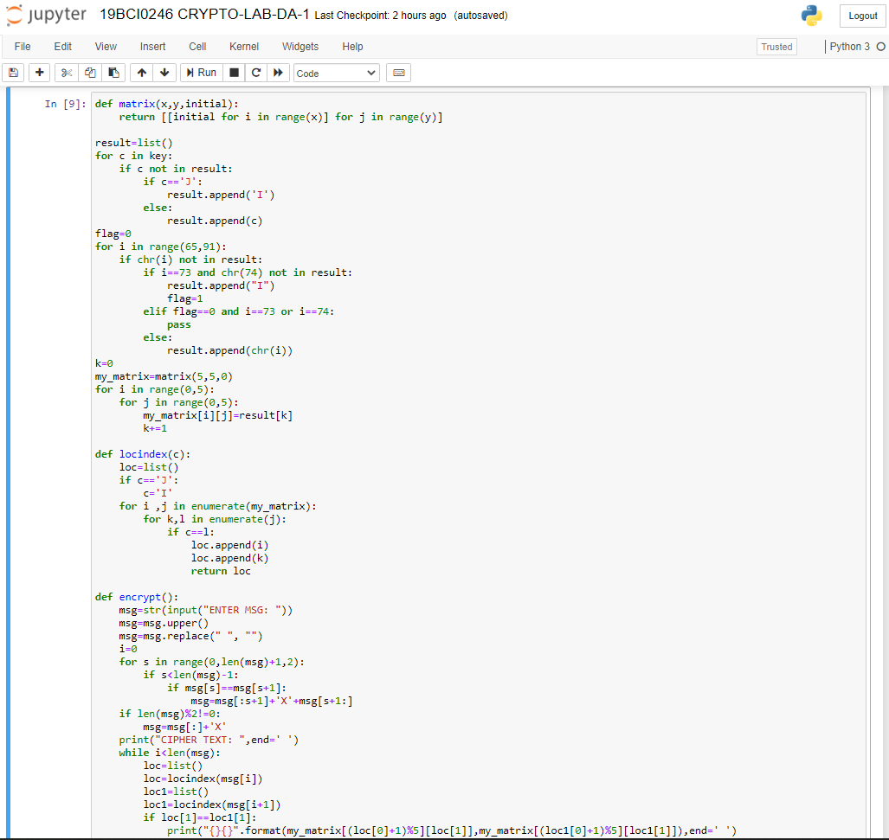

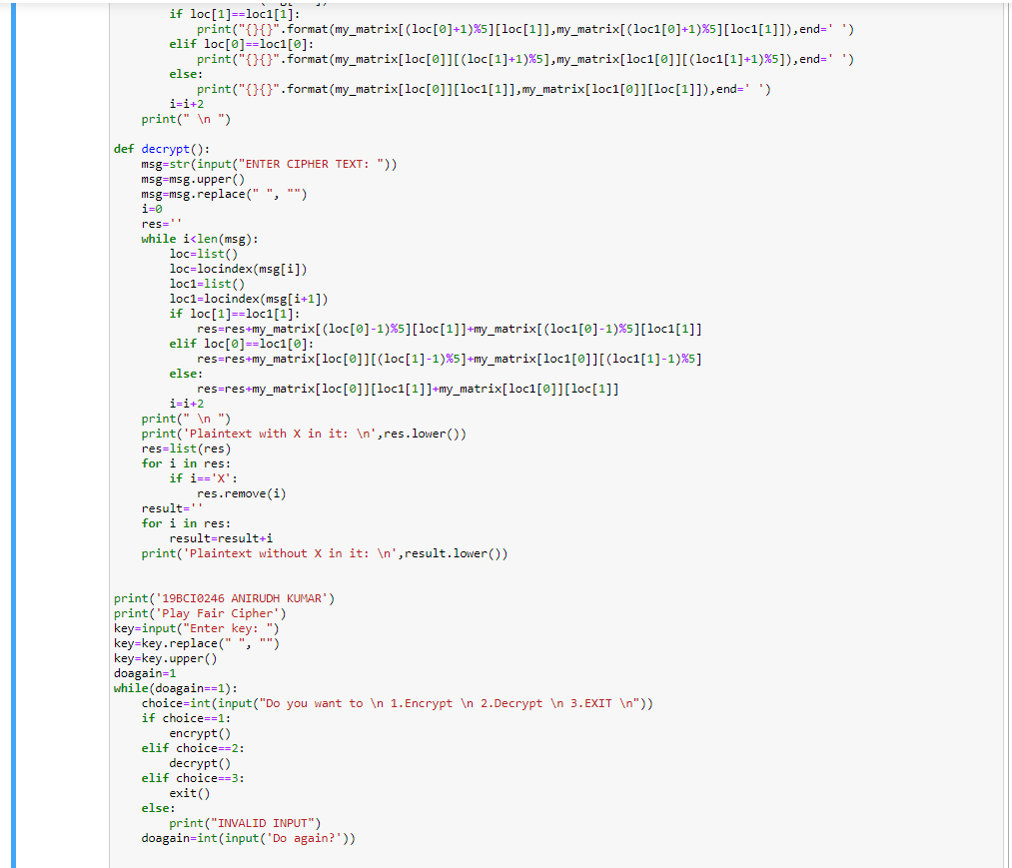

OUTPUT:

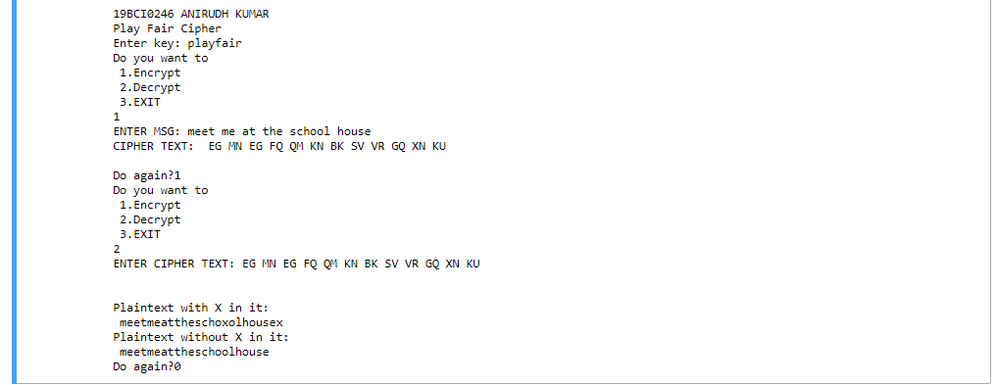

Hill cipher

Aim: To implement Hill cipher to encrypt a given text.

Procedure:

For encryption:

* The key is converted into a matrix which contains the number which that alphabet corresponds to: a=0 ….. z=25.
* The input is split into smaller pieces of size=3.
* If the input’s length is not divisible by 3, additional letters are added: x and y depending on the remainder.
* The key matrix is multiplied with the input list’s smaller matrix (which has only 3 elements). The resultant is the encrypted version of that part.
* The above step is repeated until the entire message gets encrypted.

Code:

print('19BCI0246 ANIRUDH KUMAR')

print('Hill Cipher')

keyMatrix = [[0] * 3 for i in range(3)]

messageMatrix = [[0] for i in range(3)]

resultMatrix = [[0] for i in range(3)]

result=''

def getKeyMatrix(key):

k = 0

for i in range(3):

for j in range(3):

keyMatrix[i][j] = key[k]

k += 1

def encrypt(messageMatrix):

for i in range(3):

for j in range(1):

resultMatrix[i][j] = 0

for x in range(3):

resultMatrix[i][j] += (keyMatrix[i][x] * messageMatrix[x][j])

resultMatrix[i][j] = resultMatrix[i][j] % 26

def HillCipher(message, key):

global result

getKeyMatrix(key)

for i in range(3):

messageMatrix[i][0] = ord(message[i]) % 97

encrypt(messageMatrix)

CipherText = []

for i in range(3):

CipherText.append(chr(resultMatrix[i][0] + 97))

for i in CipherText:

result=result+i

message=input('Enter a message to be encrypted: ')

message.lower()

l=[]

if(len(message)%3==1):

message=message+'x'+'y'

elif(len(message)%3==2):

message=message+'x'

else:

message=message

print(message)

for i in range(0,len(message),3):

l.append(message[i:i+3])

print(l)

key = list(input('Please enter the key matrix a=0 - z=25: \n').split())

if len(key)==9:

for i in range(len(key)):

key[i]=int(key[i])

print(key)

for m in l:

HillCipher(m, key)

print('Resultant encrypted message:')

print(result.upper())

else:

print('Please enter key of valid length')

Screenshot of code:

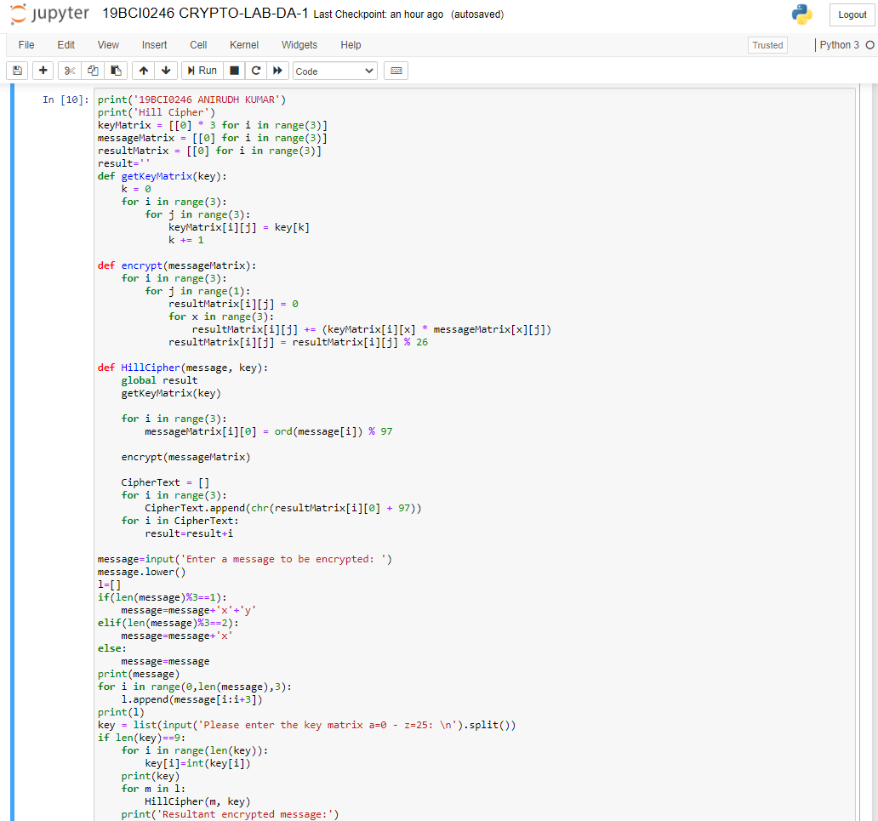



OUTPUT:

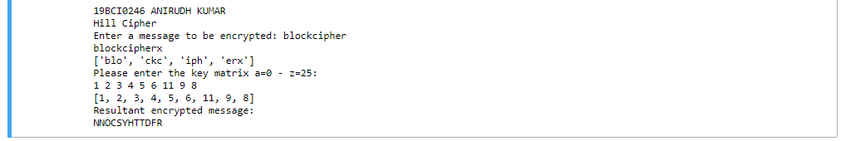

Vigenere cipher

Aim: To implement Vigenere cipher to encrypt and decrypt a given text.

Procedure:

For encryption:

* The first letter of the plaintext is paired with the first letter of the key.
* The sum of the numbers the ith letter of the key and the ith letter of the message correspond to mod 26 is the encrypted version of that letter.
* The key keeps getting repeated until the entire message gets encrypted.
* CipherTexti = (PlainTexti + Keyi) mod 26

For decryption:

* The first letter of the cipher text is paired with the first letter of the key.
* The difference of the Cipher text’s ith letter and the Key’s ith letter +26 mod 26 is the decrypted version of that letter.
* The key keeps getting repeated until the entire message gets decrypted.
* PlainTexti = (CipherTexti – Keyi +26) mod 26.

Code:

print('19BCI0246 ANIRUDH KUMAR')

print('Vigenere Cipher')

enc=''

def encrypt(p,k):

ct,i,j = "",0,0

for _ in range(len(k),len(p)):

k+=k[i%len(k)]

i = i + 1

for _ in p:

ct+=alphabet[(alphabet.find(p[j])+alphabet.find(k[j]))%26]

j = j + 1

global enc

enc=enc+ct

dec=''

def decrypt(c,k):

nk,dt,i,j = [],"",0,0

for _ in range(len(c)):

nk+=(k[i%len(k)])

i = i + 1

for _ in c:

dt+=alphabet[(alphabet.find(c[j])-alphabet.find(nk[j]))%26]

j = j + 1

global dec

dec=dec+dt

alphabet = "abcdefghijklmnopqrstuvwxyz"

doagain=1

while doagain==1:

choice=int(input('Enter 1 to encrypt and 2 to decrypt the text '))

if choice==1:

key = input("Enter the key: ").lower()

pt1 = input("Enter the plaintext: ").lower()

l=list(pt1.split())

pt=''

for i in l:

pt=pt+i

encrypt(pt,key)

print(enc)

elif choice==2:

key = input("Enter the key: ").lower()

cip1=input('Enter cipher text to be decrypted: ').lower()

l=list(cip1.split())

cip=''

for i in l:

cip=cip+i

decrypt(cip,key)

print('Decrypted message is: ',dec)

doagain=int(input('Do again? 1 to do again; 0 to stop '))

Screenshot of code:

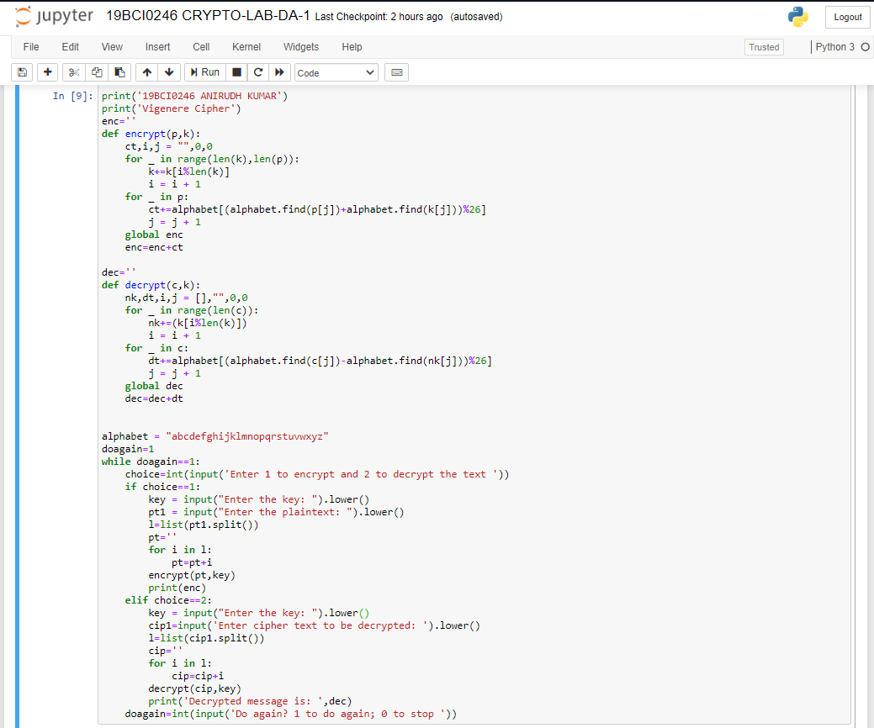

OUTPUT:

